万法归宗之英语语法速成入门
第4节：课后作业指导
作业内容及要求：
1. 结合讲过的内容和作业范例将下列五十大经典句进行句子成分全解析。
特别说明：【推荐自行打印本作业课件，方便多次联系使用。】【不差钱的同学可以彩打】
句式终极流程图
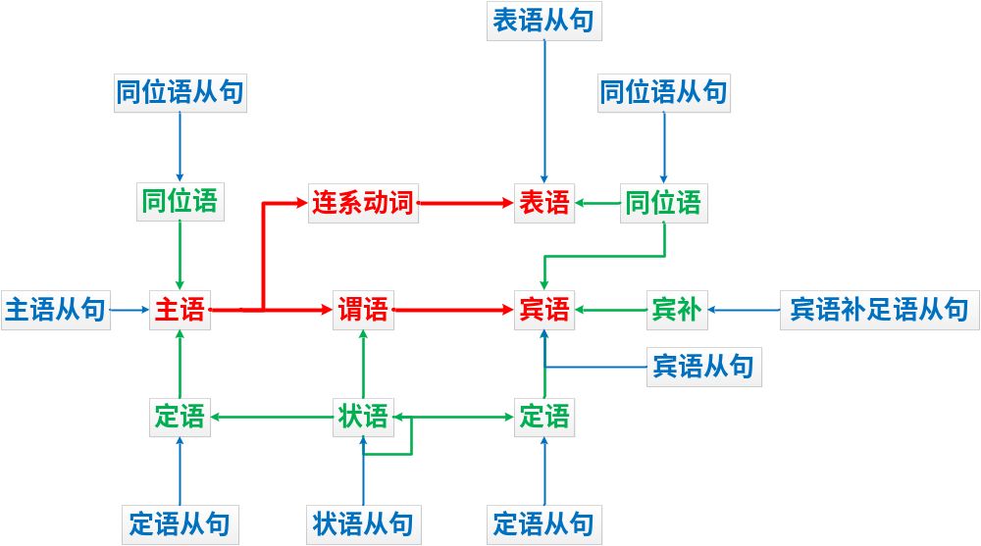
语法七要素之五：动词的时态
完整名称表 + 简化公式版
状态  时间 | 一般← | 进行 be → | 完成 have → | 完成进行 have been →
将来 will | 一般将来时  will do | 将来进行时  will be doing | 将来完成时  will have done | 将来完成进行时  will have been doing
现在 | 一般现在时  do | 现在进行时  am/are/is doing | 现在完成时  have done | 现在完成进行时  have been doing
过去 | 一般过去时  did | 过去进行时  was/were doing | 过去完成时  had done | 过去完成进行时  had been doing
过去将来 would | 过去将来时  would do | 过去将来进行时  would be doing | 过去将来完成时  would have done | 过去将来完成进行时  would have been doing
特别说明：所有的时态形式都是在助动词的基础上改变动词原有的形式或增加新的助动词拓展而来。
【天下间所有英语句子的时态形式尽皆于此】
状态  时间 | 一般 | 进行be | 完成 have | 完成进行 have been
将来 will | I will do  He will be | I will be doing | I will have done  He will have been | I will have been doing
现在 | I do  He does  I am  You are  She is | I am doing  You are doing  He is doing | I have done  He has done  You have been  She has been | I have been doing  He has been doing
过去 | I did  I was  You were | I was doing  You were doing | I had done  She had been | I had been doing
过去将来 would | I would do  He would be | I would be doing | I would have done  He would have been | I would have been doing

项目  名称 | 三大从句引导词  【入门版】【死记】
项目  名称 | 名词性从句 |  |  |  | 定语从句 |  | 状语从句
项目  名称 | 主从 | 宾从 | 表从 | 同从 | 限制性 | 非限制性 | 9大类连接词conj.：不作成分
引导词  分类 | 连接词conj.：不作成分  that 无意义  whether / if 是否 |  |  |  |  |  | 时间 | when, while, before, after, until, till, once, every time, since, as soon as…
引导词  分类 |  |  |  |  |  |  | 条件 | if, unless, as long as…
引导词  分类 |  |  |  |  |  |  | 原因 | because, for, as, since…
引导词  分类 | 连接代词pron.：主，宾，表，定  who (whom)表人  what 表物  which 表选择，哪个  whose 表所属，谁的 |  |  |  | 关系代词pron.：主，宾，表，定  that 表人或物  who (whom)表人  which 表物  whose 表所属，谁的 |  | 结果 | so…that…; such…that…
引导词  分类 |  |  |  |  |  |  | 目的 | so that…; in order that…
引导词  分类 |  |  |  |  |  |  | 让步 | even if, even though, although; though  no matter what/how…  wh- + -ever…
引导词  分类 | 连接副词adv.：时间状语，地点状语；原因状语；方式状语  when 表时间  where 表地点  why 表原因  how 表方式 |  |  |  | 关系副词adv.：时间状语，地点状语；原因状语  when 表时间  where 表地点  why 表原因 |  | 比较 | than…; as…as…
引导词  分类 |  |  |  |  |  |  | 地点 | where
引导词  分类 |  |  |  |  |  |  | 方式 | as if…; like…; as…

Beautiful English for Practice
作业范例：
No. 1: A genius is the person who repeats the most times!
主 系 表 定语从句
主 谓 定 宾
No. 2: God helps those who help themselves.
主 谓 宾 定语从句
主 谓 宾
No. 3: It is impossible to defeat a person who never gives up.
形主系 表 主（真正的主语）
非谓 宾 定语从句
主 状 谓

No. 4: If you don’t try, you will never succeed.
条件状语从句 主 状 谓
主 谓
No. 5: What you do today is what matters most.
主语从句 系 表语从句
宾 主 谓 时状 主 谓 状
还有45句需要你们自己完成哦！
No. 6: It is a great honor for me to be here in Shanghai, and to have this opportunity to speak with all of you.

No. 7: I will greet this day with love in my heart.

No. 8: Challenges are what make life interesting; overcoming them is what makes life meaningful.

No. 9: The way to have a better tomorrow is to start working on it today.

No. 10: No one can get anywhere unless he knows where he wants to go and what he wants to be or do.

No. 11: The more failures, the more chances for success. Success is usually the last-minute visitor.

No. 12: Be thankful for each new challenge, because it will build your strength and character.

No. 13: Victory won’t come to me unless I go to it.

No. 14: A man is not finished when he is defeated. Only he is finished when he quits.

No. 15: We struggle painfully today to create an amazing future.

No. 16: Life is brief. Let’s make it wonderful!

No. 17: Education doesn’t do us much good unless it is mixed with sweat.

No. 18: The outer conditions of a person’s life will always be found to reflect their inner beliefs.

No. 19: Every great achievement is the result of a heart on fire.

No. 20: Everything that is done in the world is done by hope.

No. 21: Of all human resources, the most precious one is the desire to improve.

No. 22: Genius only means working hard all one’s life.

No. 23: The more prepared you are, the more confidence you will have.

No. 24: The difference between a successful person and others is not a lack of strength, not a lack of knowledge, but rather a lack of will.

No. 25: Keep your face to the sunshine and you can never see the shadow.

No. 26: Love makes the world go around.

No. 27: Most people are about as happy as they make up their minds to be.

No. 28: If you are doing your best, you will not have to worry about failure.

No. 29: You have to have a dream so you can get up in the morning.

No. 30: There is no elevator to success. You have to take the stairs.

No. 31: I have not failed. I’ve just found 10,000 ways that won’t work.

No. 32: Change your thoughts and you change your world.

No. 33: Great things are accomplished by talented people who believe they will accomplish them.

No. 34: No man ever fails until he fails on the inside.

No. 35: The surest way not to fail is to determine to succeed.

No. 36: Life is like riding a bicycle. To keep your balance you must keep moving.

No. 37: Set your goals high, and don’t stop till you get there.

No. 38: The important thing is to learn a lesson every time you lose.

No. 39: Struggle is the only correct way for human beings!

No. 40: Where there is great love, there are always miracles.

No. 41: If you put enough effort into achieving a result, you will almost certainly achieve it.

No. 42: I had the blues because I had no shoes until upon the street, I met a man who had no feet.

No. 43: To be the best, you have to be with the best.

No. 44: Even if you are strong, faith will make you stronger.

No. 45: Nothing is impossible to a willing heart.

No. 46: Talent is enduring patience.

No. 47: Courage and resolution are the spirit and soul of virtue.

No. 48: If you want to be a successful person, then the first thing you must do is change some of your habits.

No. 49: The price of excellence is discipline.

No. 50: If you want to be happy, set a goal that commands your thoughts, liberates your energy and inspires your hopes.

